Information on tourist spots around Ojiya

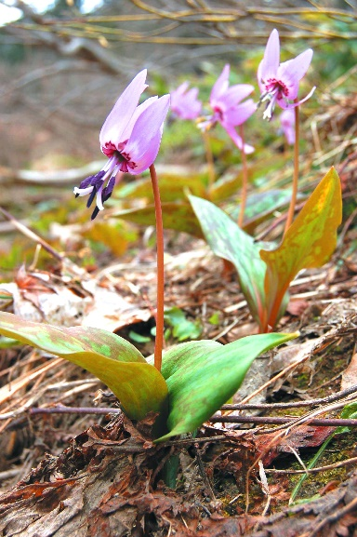 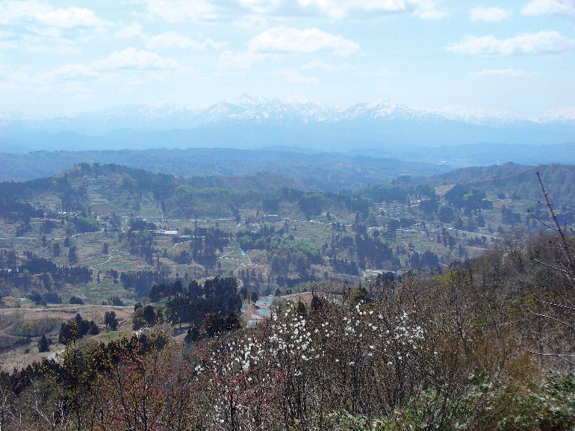
Mt. Kanagura

Mt. Kanagura stands on the boundary between Ojiya and Nagaoka. It is 581m high. There is a path for walkers from the foot of mountain to the top. Throughout a year you can enjoy different kinds of wild grasses and flowers: dogtooth violet, viola brevistipulata and daffodil which is the official city flower in Spring, kaempferi azaleas and cirsium vulgare in Summer, and colored leaves in Autumn. Due to its moderate slopes and tree-shadowed path, it is a relatively easy mountain to hike.
From the viewing platform on top of the mountain, you can see the spectacular view of the Japan sea and the terraced ponds in Yamakoshi. It will make you feel calm and refresh your mind.

